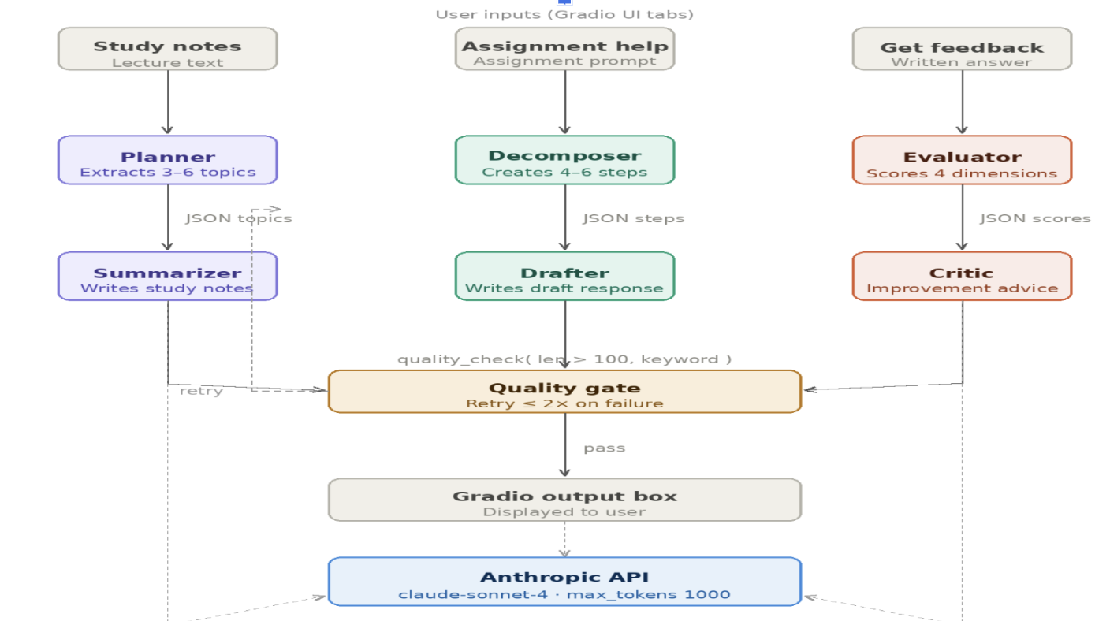

1. System Overview
The AI Study Assistant is a multi-agent application built on top of the Anthropic Claude API. It routes three distinct academic workflows through purpose-built agent pipelines, each composed of two sequential LLM calls. A shared quality gate sits between every pipeline and the UI, enforcing a minimum output standard and triggering automatic retries when that standard is not met.

The application is served via Gradio, which provides a tabbed chat interface. Each tab corresponds to one pipeline. All agents call the same underlying Claude Sonnet model through a shared helper function, keeping the integration surface minimal and consistent.

2. Agent Roles, Inputs, and Outputs
The system contains six agents organised into three two-stage pipelines. Within each pipeline, the first agent structures the problem, and the second agent produces the human-readable deliverable.

Agent | System role | Input | output
Planner | Study planner | Raw lecture notes or reading text | JSON: {"topics": [{"name": str, "estimated_minutes": int}]}
Summarizer | Study notes | JSON topic list from Planner | Markdown study notes with Key Concepts, Study Plan, and Summary sections

The Planner extracts between three and six key topics from unstructured text, estimating the study time required for each. The Summarizer receives this structured topic list and produces formatted study notes. The quality gate checks that the output exceeds 100 characters and contains the word "concept".

Agent | System role | input | output
Decomposer | Assignment planner | Assignment description from user | JSON: {"steps": [{"number": int, "action": str, "description": str}]}
Drafter | Academic writing assistant | JSON step list from Decomposer | Structured writing guide plus a draft response paragraph

The Decomposer breaks an assignment prompt into four to six concrete, ordered steps. The Drafter uses those steps as a scaffold to produce both a structured writing guide and a sample draft paragraph. The quality gate checks for length and the presence of the word "step".

agent | System role | input | output
Evaluator | Academic evaluator | Written answer or draft from user | JSON: {"clarity": int, "accuracy": int, "completeness": int, "structure": int, "overall_comment": str} — each score 1–5
Critic | Academic critic | JSON rubric scores from Evaluator | Specific, encouraging improvement suggestions for each dimension plus an overall summary

The Evaluator scores the submission across four rubric dimensions (Clarity, Accuracy, Completeness, and Structure) on a 1–5 scale. The Critic converts those scores into actionable, encouraging coaching notes. The quality gate checks for length and the presence of the word "clarity".

All agents communicate with the Claude model using a shared function called call_claude(). This function sends a system prompt and user input to the model and returns the generated text. Each call is independent, meaning there is no shared memory or conversation history between agents. Because of this, the output from the first agent must be complete and clear enough for the second agent to understand and use effectively.

Data is passed between agents as plain text, typically in JSON format. However, there is no formal validation of this JSON. Instead, the second agent is expected to interpret the output using natural language understanding. While this approach keeps the system simple, it can also introduce potential errors if the JSON is not properly formatted.

The system runs synchronously, meaning each pipeline executes from start to finish in a single flow when triggered by the user. There is no use of asynchronous processing, message queues, or shared state storage. This design choice simplifies implementation but may limit scalability and flexibility.

Overall, the AI Study Assistant demonstrates a clear and effective multi-agent design. By separating the structuring and generation tasks, it creates more organized and useful outputs for students. While the system is simple and functional, enhancing error handling, validation, and efficiency would make it more robust and reliable for real-world use.

